PRACTICAL QUESTIONS FOR DATA VISUALISATION AND ANALYTICS (CIA1C11)
Practical 7 – Data Preparation and Analytics III (Data Reduction)

Introduction: By going through the process seen in Practical 2-6, the data analyst would have done most of the work needed for EDA & Data Preparation. He/she could even have analyzed the data and did some work in descriptive analytics already. What if the data analyst wishes to progress to the next stage for Predictive Analytics?
There are two things to consider. First, in Predictive Analytics, many machine learning algorithms are used to train the machines to do predictions. Secondly, with recent explosion in big data, it means that the data size collected can have many more rows as well as many more columns.
However, more is not always better. Huge amount of data can sometimes create too much noise for the machine to learn efficiently. Hence, the performance of the machine learning algorithms can become slower and slower on a growing number of data columns. There is therefore a need to reduce the number of data columns (a.k.a. dimensions) before embarking on Predictive Analytics, and yet ensuring suitable level of data integrity.
It is for this reason that we now learn some additional data preparation techniques to handle dimensionality reduction, such as removing high missing-value ratio columns, highly correlated columns and low variance columns.

Objective: The aim of Practical 7 is to focus on some data preparation techniques for dimensionality reduction.

Question 1 : To clean (split, standardize), transform (re-code), reduce dimensionality
Question 2 : To analyze the prepared data using visualizations
Question 3 : To publish visualization to the cloud

Dataset: For our task this week, we will make use of a dataset containing a list of malicious and benign websites URL and their corresponding application layer and network characteristics.

The data were obtained by using different verified sources of benign and malicious URL's, in a low interactive client honeypot to isolate network traffic. For more details, you can visit this link (https://www.kaggle.com/xwolf12/malicious-and-benign-websites)

Some modifications were made to the dataset so that we could practice some of the data preparation techniques. The description of fields in the dataset is presented below.

Field | Description
URL | Anonymized URL of websites studied
SPECIAL CHAR IN URL | Number of special characters such as /, %, #, &, = in the URL, out of total number of characters in the URL.
CHARSET | Character encoding standard of the website
SERVER | The operating system of the web server
CONTENT_LENGTH | Size of HTTP header in bytes
ACCEPT_EN | Accepted encoding format obtained from HTTP header
WHOIS_COUNTRY | Country in server response to Whois API call
WHOIS_STATEPRO | State in server response to the Whois API call
WHOIS_REGDATE | Server registration date in DD/MM/YY HH:MM format
WHOIS_UPDATED_DATE | Last update date of server
TCP_CONVERSATION_EXCHANGE | Number of TCP packets exchanged between server and honeypot client
DIST_REMOTE_TCP_PORT | Number of ports detected and different from TCP ports
REMOTE_IPS | Total number of IPs connected to the honeypot
APP_BYTES | The number of bytes transferred
SOURCE_APP_PACKETS | Packets sent from the honeypot to the server
REMOTE_APP_PACKETS | Packets received from the server
SOURCE_APP_BYTES | The number of bytes transferred from honeypot to server
REMOTE_APP_BYTES | The number of bytes transferred from server to honeypot
APP_PACKETS | Total number of IP packets generated during the communication between the honeypot and the server
DNS_QUERY_TIMES | Number of DNS packets generated during the communication between the honeypot and the server
TYPE | Classification of web page. 1 = malicious websites, 0 = benign websites

Ready? Let’s get started!

Question 1 (Split String, String manipulation, Dimensionality Reduction, Recode)
The purpose of this question is to learn to:
- clean data (split data, standardize pattern),
- transform data (recode) and
- reduce dimensionality (for high missing-value ratio, highly correlated, low variance columns)

- Read Data
Create a new KNIME Workflow, label it as “P07”.
We will use the dataset Websites URL modified.csv for this question.

Add a File Reader node and read the dataset using default settings.
Verify that you have 1781 rows, 21 columns.

- Clean Data - Split Cell
We will start by handling the SPECIAL CHARACTER IN URL field. This field is in the form X:Y where X represents the number of special characters such as %, $, #, & in the website’s URL and Y represents that total number of characters in the URL.

This field is holding two pieces of numeric information but storing it as a string. Let’s split this field into two, so that we can make use of the numeric data.
Add a Cell Splitter node. Select SPECIAL CHARACTER IN URL as the field to split.
Enter colon (:) as the delimiter.

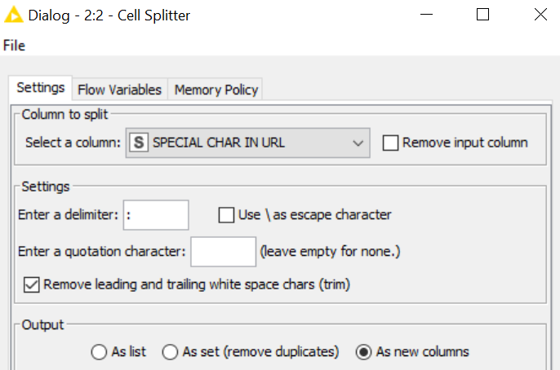

Run the Cell Splitter node, verify that you are have two new columns. They should be appended to the right side of the table.

- Dimensionality Reduction - Remove Redundant Column
Since we have already split the SPECIAL CHARACTER IN URL field into two other fields, we do not need the original field. Add a Column Filter node to drop it (exclude this column in left panel).

- Clean Data - Rename Split Columns
Add a Column Rename node downstream, rename the two newly generated fields, as NUMBER SPECIAL CHAR and TOTAL URL LENGTH respectively.
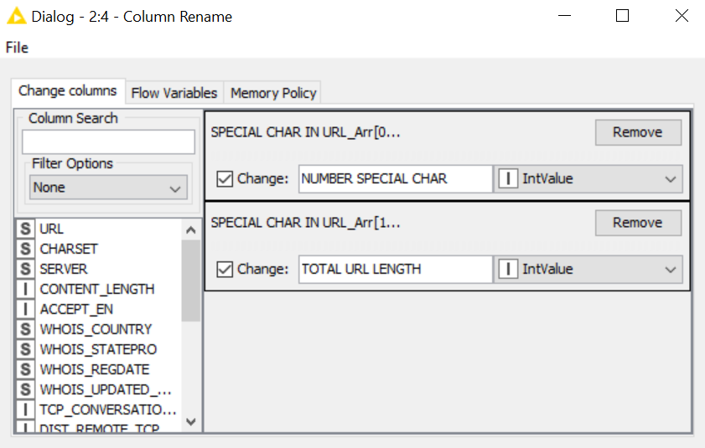

- Clean Data - Standardize to Upper Case Letter
Both the CHARSET and SERVER fields contained a mixture of upper and lower case for similar values (e.g. utf-8 and UTF-8). We need to standardize this.
Add a String Manipulation node downstream and convert the field to uppercase using the upperCase() function.
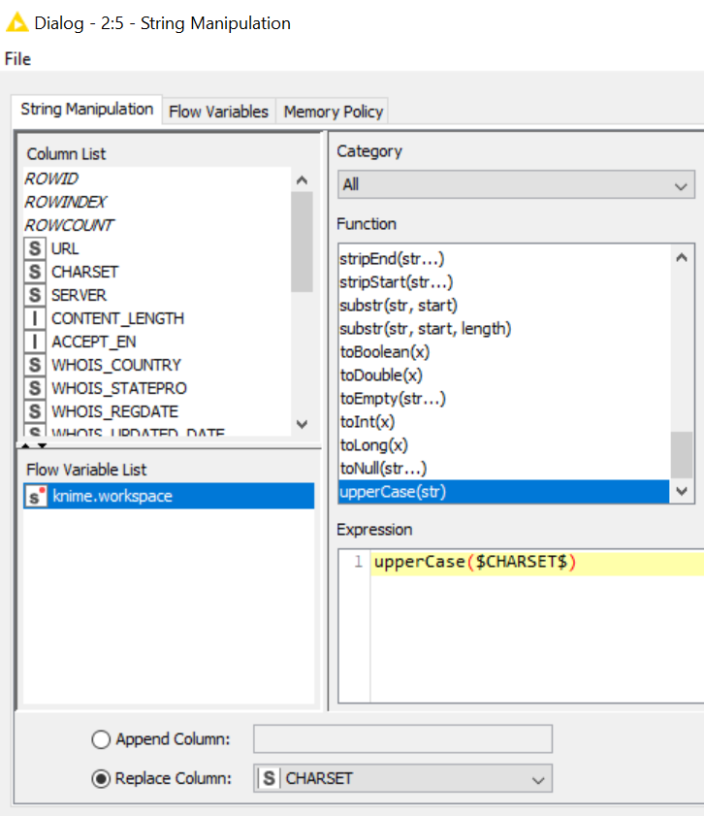

- Clean Data - Standardize to Upper Case Letter
Add another String Manipulation node, carry out the same treatment for the SERVER field.
Your stream should resemble the one shown below.

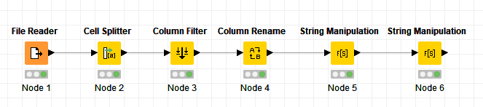

Check that there are 22 columns at this point.

- Dimensionality Reduction - High Missing-Value Ratio
We will try some dimensionality reduction methods in the next few steps. The first method we will explore is the removal of columns that contain too many missing values. Columns containing too many missing values would very likely not be useful for any downstream analysis tasks that we plan to carry out.

Add a Missing Value Column Filter node downstream, set the missing value threshold to be 20%.

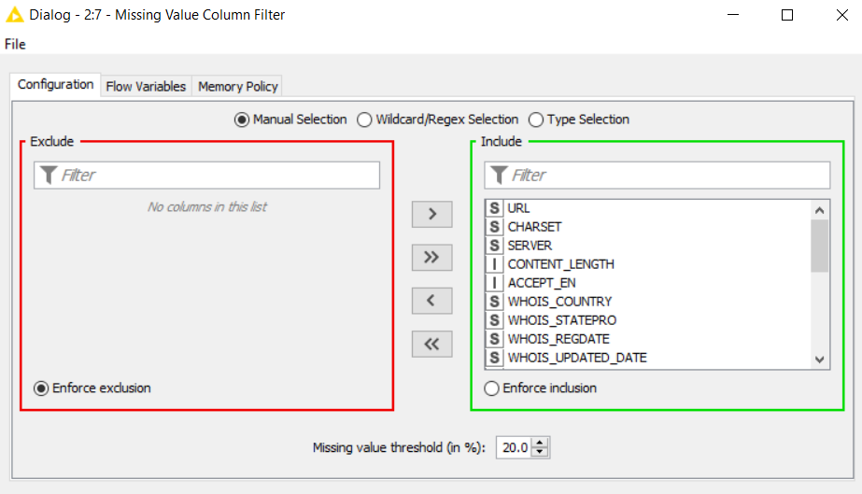

Execute the node and take note of the number of columns remaining. Notice that only 21 columns are left.

 | Discussion: Which column(s) was/were removed?  Can we use one of the imputation techniques, instead of removing the column?
Answer:

CONTENT_LENGTH field was removed.
If the percentage of missing value is too high, most imputation techniques would not work well also.

- Dimensionality Reduction - Highly Correlated Columns
Next, we will try to remove fields that are highly correlated. The rationale behind this method is that high correlation between fields indicate that the fields carry similar information. A data column containing values that are highly correlated to values in another column will not add much new information to the downstream analysis that we plan to carry out.

In order to remove highly correlated data columns, we first need to measure the correlation between pairs of columns using the Linear Correlation node, then we apply the Correlation Filter node to remove one of two highly correlated data columns, if any.

Add a Linear Correlation node downstream from the Missing Value Column Filter node. Execute the Linear Correlation node. You would get a warning about missing values, but for our purpose, it is alright.

Check : What is TCP Conversion Exchange highly correlated to?

Next, we will remove fields that are highly correlated. Add a Correlation Filter node. This node requires 2 inputs from you:

- The top (square) input port expects a correlation model, connect the bottom (square) output port from the Linear Correlation node to it.
- The bottom input (arrow) port of the Correlation Filter node expects the data table on which to apply the filter. Connect the output port of the Missing Value Column Filter node to this input.
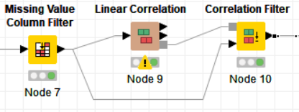

Open the configuration window for the Correlation Filter node.

You can use the slider to adjust the correlation threshold for which fields would be removed.
You can use the slider to make the adjustment or enter the threshold. Enter 0.95 as the threshold.

You can click on the Calculate button to see the number of fields that would be included / excluded by the filter. Fields that are excluded will not be highlighted.

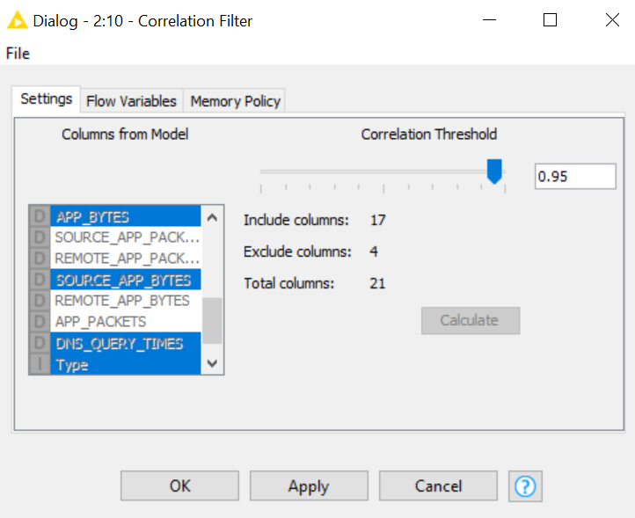

Execute the Correlation Filter node.
 | Discussion: Which column(s) was/were removed? Which of the remaining column(s) do you think the removed column(s) was/were correlated to?
Answer:

A total of 4 columns were removed.
- SOURCE_APP_PACKETS
- REMOTE_APP_PACKETS
- REMOVE_APP_BYTES
- APP_PACKETS

They were correlated to TCP_CONVERSATION_EXCHANGE and APP_BYTES

- Dimensionality Reduction – Low Variance Columns
The last dimensionality reduction technique we are going to try is the low variance filter. The idea behind removing fields with low variance is such fields would contain largely constant values, they would likely distract certain learning algorithms, particularly those which are distance based.

Add a Low Variance Filter node downstream from the Correlation Filter node.
Low variance filter only works on numeric values, select all numeric fields except Type.
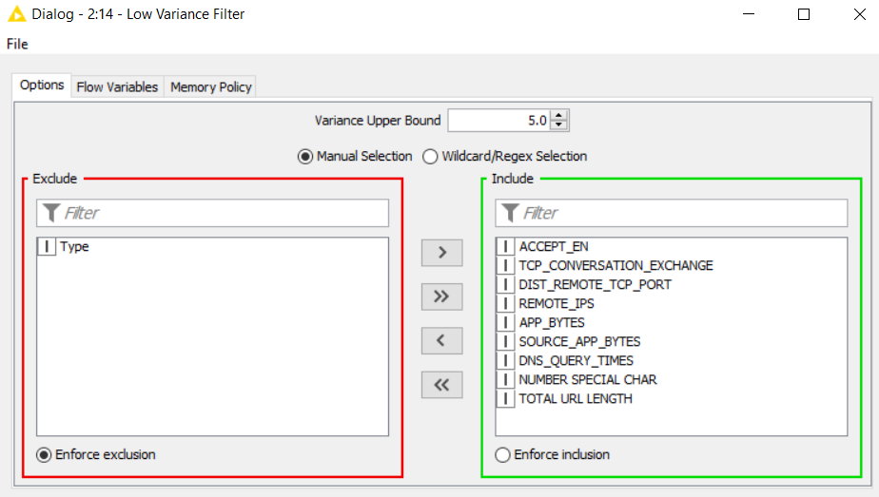

For this exercise, we will set the variance threshold to be 5 (higher threshold, more fields removed).

Take note that we have arbitrarily selected 5 as the threshold. It is important that you experiment with different values for the variance threshold that would not be overly intense in the removal of fields.

Execute the Low Variance Filter node. You should have 16 fields remaining.

 | Discussion: Why did we exclude the Type field for Low Variance Filter?
Answer:

The Type field is essentially a binary variable, 1 representing malicious websites and 0 representing benign websites. It is not really a numeric field, so computing the variance would not make sense. KNIME does not know this, but you as a human user needs to be mindful of such coded ‘numeric’ fields.

- Transform Data – Recode
We will recode the Type field.
Add a Rule Engine node downstream from the Low Variance Filter.
Add rules such that:
Type = 1 will be recoded to “Malicious”, and
Type = 0 will be recoded to “Benign”.
Otherwise, it will be recorded to “Others”
Select the option to replace Type column.

- Write to CSV file
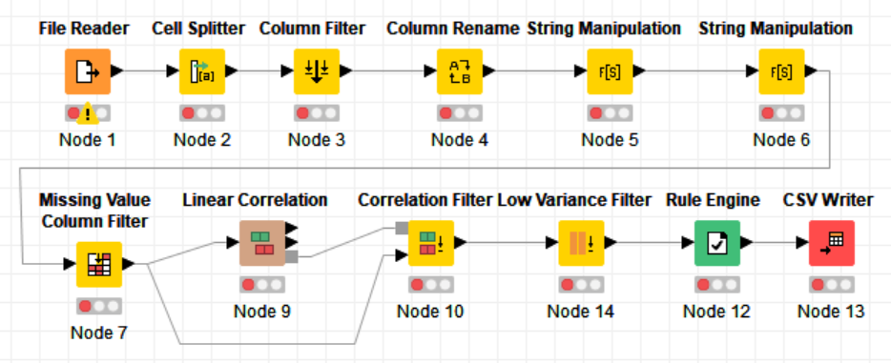
Add a CSV Writer node downstream. Save the prepared data as P07.csv to an output location of your choice. Be sure to check the option for Column header and Row ID. If file exists, overwrite it. Your workflow should resemble the one shown below. Save your workflow.

Question 2 (Visualizing the prepared data)
We will now read the CSV file prepared in Question 1 into Power BI desktop. This will allow us to prepare visualizations using stacked column chart, clustered column chart, map and pie chart.
In the process of exploring the data, we may be able to discover things such as:
- Can we determine if websites are malicious and benign based on characteristics of the web server (character set, Server OS)?
- Can we determine if websites are malicious and benign based on characteristics of the URL (URL length, number of special characters)?
- Can we determine if websites are malicious and benign based on the HTTP traffic exchanges (number of distinct TCP ports, DNS query times)?
- Are malicious websites mostly hosted at a few countries?

For Mac Users : Use Power BI Service

Sign in to Power BI Service (in the cloud) Click Get Data Click Get Under File Select Local File Navigate to P07.csv and select file. You should see the dataset P07.csv in Power BI Service. Click ⁞ next to P07.csv Select Create Report. A blank canvas will appear in Report View. You can then continue to step 2.

- Get Data
Launch Power BI desktop and create a new report. Click File > Get Data > Text/CSV.
Read the P07.csv file in the previous question into Power BI.

- Stacked Column Chart
Let us start by investigating if the character set of the web server can give us an indication of whether the site is malicious or benign.
Select to build a Stacked column chart (top row, second from left viz).
- Select Type to be Axis
- Select CHARSET to be Legend
- Select row ID to be Value make sure aggregation is Count
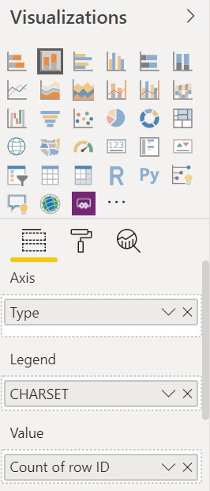
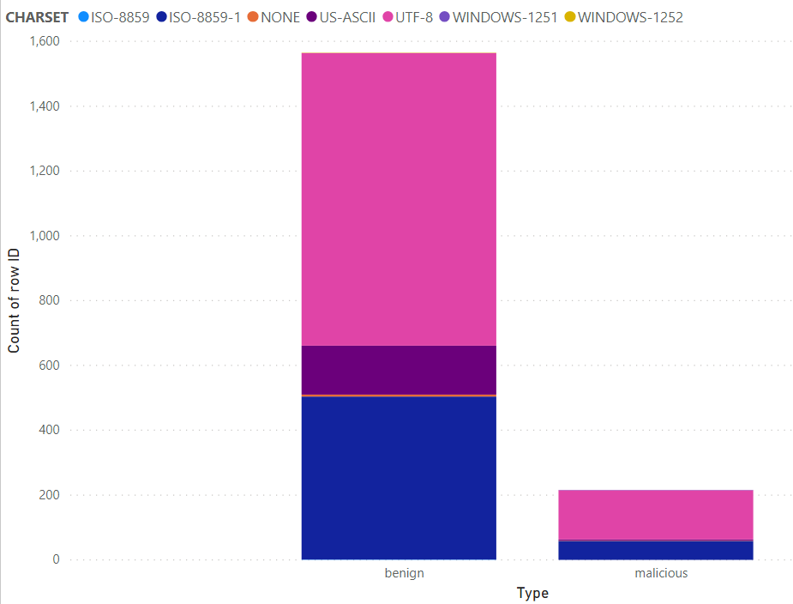

As we have an unbalanced collection of benign and malicious websites in our dataset, it is difficult for us to tell if the character set can really help us identify the type of the websites.

This is a small problem which we can solve easily. We can standardize the two columns by making a small change to the chart type.

Ensure that you have your stacked column chart selected (handles around it), click on the 100% Stacked column chart (top row, rightmost viz).
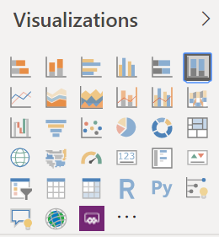

 | Question:  - Can we determine if websites are malicious and benign based on characteristics of the web server (character set, Server OS)?
Answer:

- Clustered Column Chart
Let’s add another viz. This time, we will add a Clustered column chart (top row, 4th from left viz).
- Select Type to be Axis
- Select the following as Value
  - TCP_CONVERSATION_EXCHANGE,
  - DIST REMOTE TCP PORT,
  - DNS QUERT TIMES,
  - REMOTE IPS,
  - NUMBER SPECIAL CHAR, and
  - TOTAL URL LENGTH
- Make sure aggregation is Average (right click change sum to average)

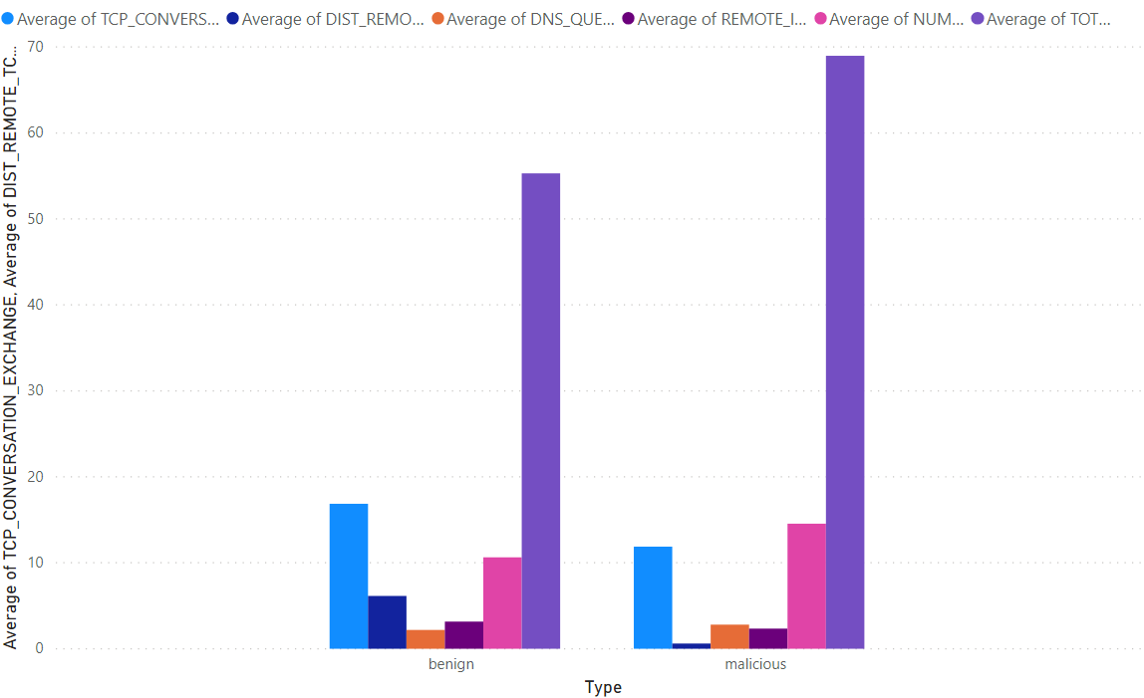
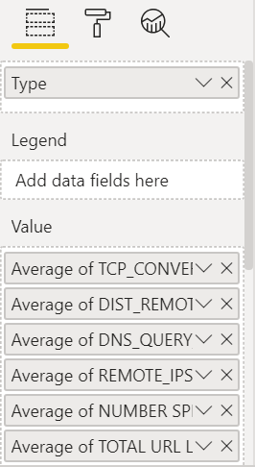
 | Question:  - Can we determine if websites are malicious and benign based on characteristics of the URL (URL length, number of special characters)?  - Can we determine if websites are malicious and benign based on the HTTP traffic exchanges (number of non-TCP ports, DNS query times)?
Answer:

- Map Visualization
We will add one more viz.
Click on an empty space on your worksheet.
Next, click on the field WHOIS_COUNTRY
You would notice that a Map viz is created.

- Select Type to be Legend
- Select row ID to be Size make sure aggregation is Count
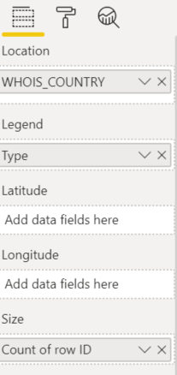
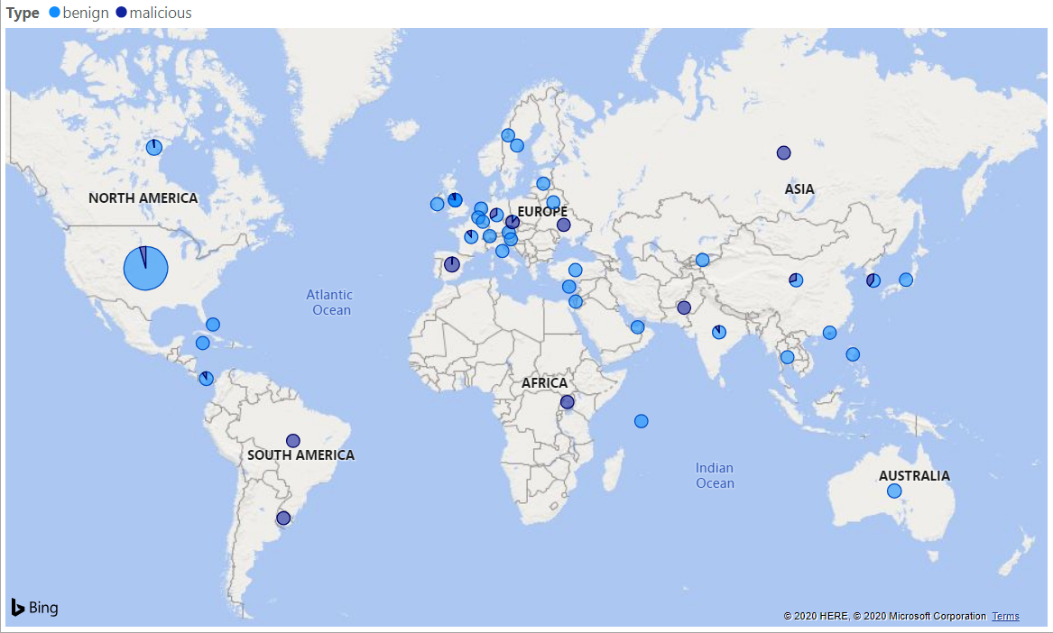

 | Question:  - Are malicious websites mostly hosted at a few countries?
Answer:

- Pie Chart
Let’s add a final viz, add a Pie chart showing the breakdown of malicious and benign websites.
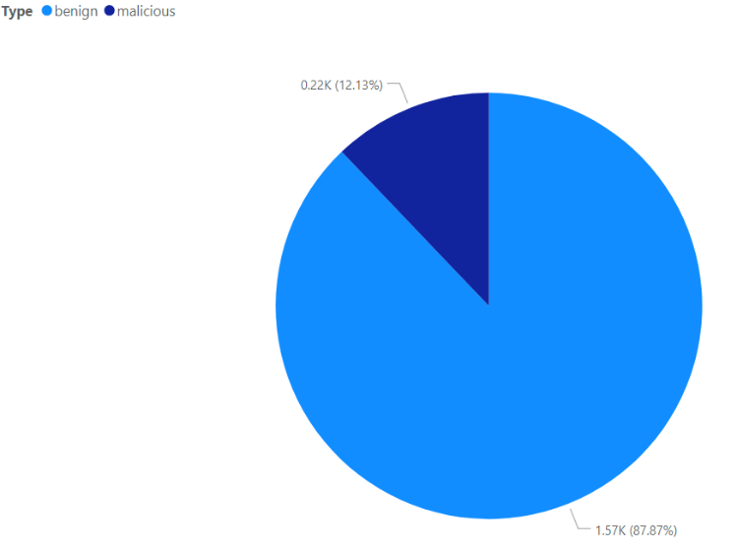

Save your report. We will use it in the next question.

Question 3 (Publishing to the cloud)
We will now explore publishing the report to Power BI Service on the Cloud.

The main difference between Power BI Desktop and Power BI Service is that desktop resides in your computer while service is a cloud-based. Publishing your work to the cloud makes it easy for you to share it with others.

However, our focus on publishing the report produced in Question 2 to Power BI Service is not so that we can share it with others, we want to make use of a feature that, at the time of development of this practical, is only available in Power BI service.

- Publish Report
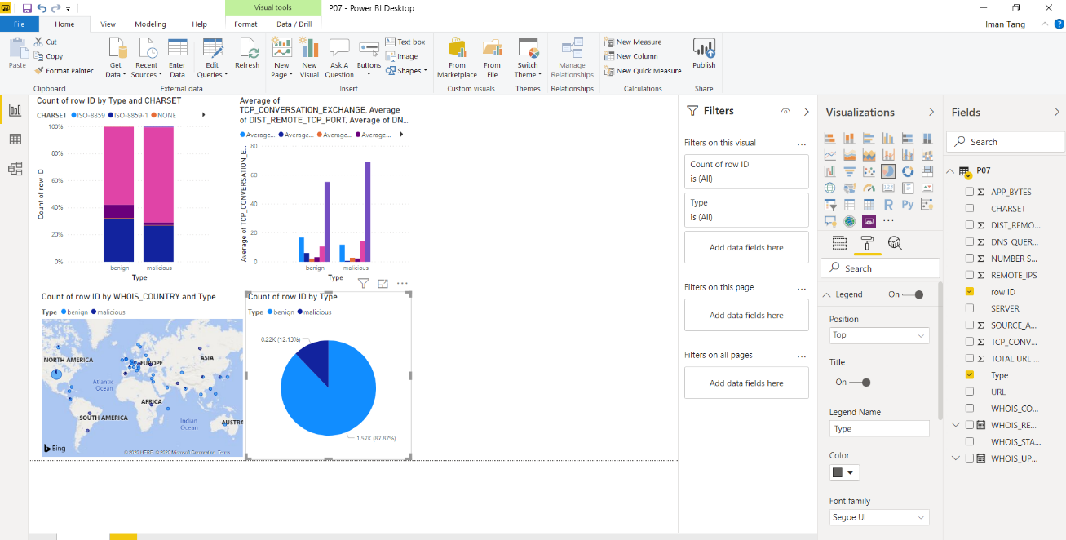
Click on the Publish button in the menu bar.

When prompted to sign in, enter your student email and password. You will be prompted on the destination workspace, we will leave it as the default – My workspace.

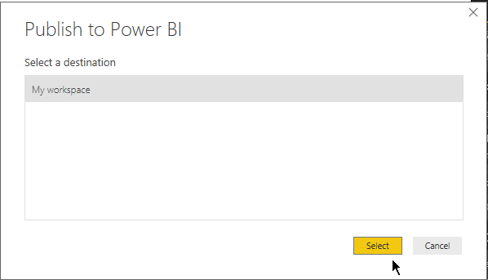

- Go to Power BI in the Cloud
In the resulting window, click on the link “Open ….. in Power BI”
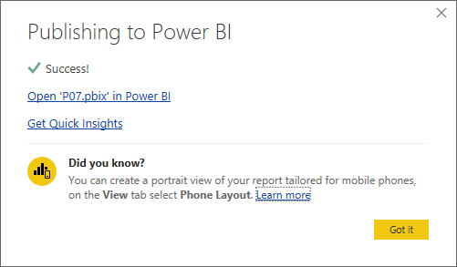
If you have accidentally closed this window, don’t worry.
Go to https://powerbi.microsoft.com/en-us/ and select Sign in. Use your TP email.

Focus your attention to the left panel of Power BI service.
The general categories of items in Power BI Service consists of DATASETS, WORKBOOKS, REPORTS and DASHBOARD.

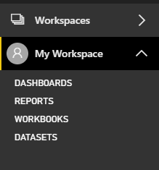

Since we had published our report with default publishing settings, the underlying dataset was also published into Power BI. You will see it when you expand the DATASETS group.

You should also find your report when you expand the REPORTS group.

- Create Dashboard
Expand the REPORTS group and locate your published report. (Screenshot below is different from what you would see because I have other published reports)

Hover over the Pie Chart and click on the thumbtack icon.
This action pins the visual to a dashboard.

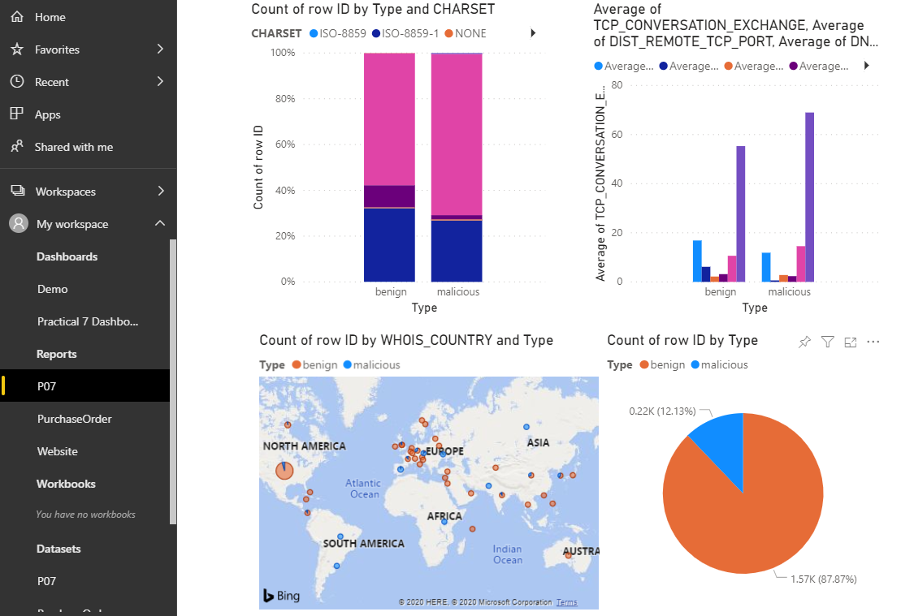
You will be prompted to pin the visual to either an existing dashboard or to create a new dashboard. Select new. I am naming mine Practical 7 Dashboard and using the destination theme.

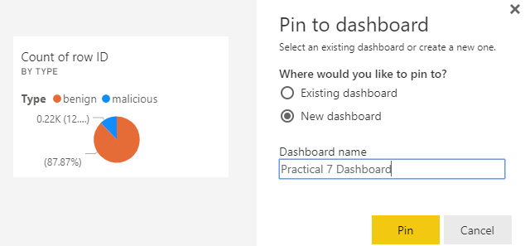
- Use Augmented Analytics to Get Insights
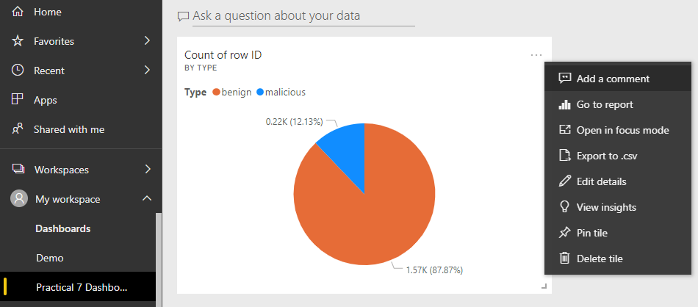
Expand the DASHBOARD group and locate the newly created dashboard. (Screenshot below is different from what you would see because I have other dashboards)
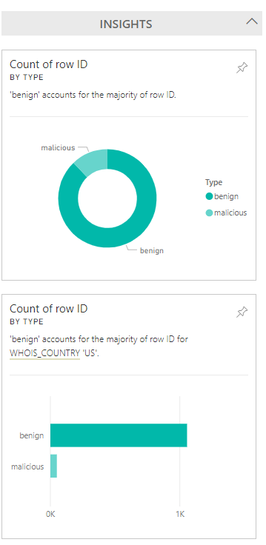
. . .

Click on the ellipsis on the Pie Chart and select View insights. This will automatically generate insights based on the underlying data.

You can scroll through the insights and see if anything catches your attention.

Question 4 (Practice Question – Will not be covered in class)
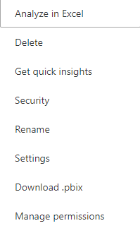
- There is another way to call this feature. Go to My Workspace, click on Datasets. Go to the dataset that you are interested in, click on the ellipsis and select Get quick Insights. Try it out.

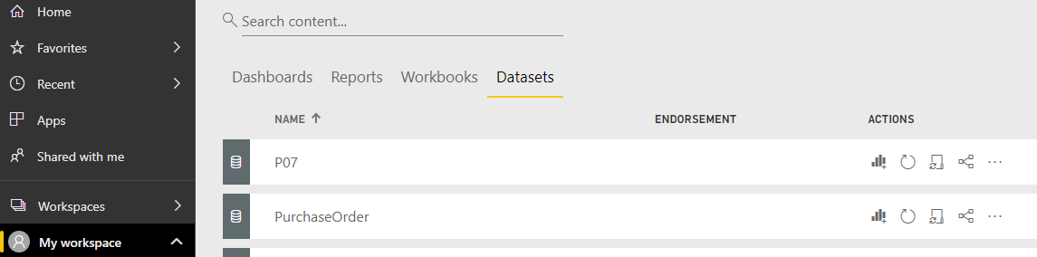

- Click View insights to go through the generated insights and pin the more interesting ones to your dashboard.


– End of Practical 7 –

 | Summary
In this practical, we looked at data preparation techniques involving string manipulations (e.g. splitting cells based on pre-defined delimiter), we also looked at how we can carry out dimensionality reduction using techniques such as missing value filtering, high correlation filtering and low variance filtering.

In this practical we made use of the following new nodes (not covered in previous practical) in KNIME.
Node |  | Purpose | Remarks
Cell Splitter |  | This node uses a user-specified delimiter character to split the content of a selected column into separate fields. | Nil
Missing Value Column Filter |  | This node removes all columns from the input table which contain more missing values than a certain percentage. | Nil
Correlation Filter |  | This node uses the model as generated by a Correlation node to determine which columns are redundant (i.e. correlated) and filters them out. | You can adjust the threshold and determine the number of fields that will be dropped in the node configuration window.
Low Variance Filter |  | Filters out columns whose variance is below a user defined threshold. Columns with low variance are likely to distract certain learning algorithms | Higher threshold means more columns removed.

